CS 305 Project One Template

Document Revision History

Version | Date | Author | Comments
1.0 | 1/22/2026 | Parker Burkard | First Edition

Client



Instructions
Submit this completed vulnerability assessment report. Replace the bracketed text with the relevant information. In this report, identify your security vulnerability findings and recommend the next steps to remedy the issues you have found.

- Respond to the five steps outlined below and include your findings.
- Respond using your own words. You may also include images or supporting materials. If you include them, make certain to insert them in the relevant locations in the document.
- Refer to the Project One Guidelines and Rubric for more detailed instructions about each section of the template.

Developer
Parker Burkard

1. Interpreting Client Needs
Determine your client’s needs and potential threats and attacks associated with the company’s application and software security requirements. Consider the following questions regarding how companies protect against external threats based on the scenario information:

- What is the value of secure communications to the company?
- Are there any international transactions that the company produces?
- Are there governmental restrictions on secure communications to consider?
- What external threats might be present now and in the immediate future?
- What modernization requirements must be considered, such as the role of open-source libraries and evolving web application technologies?

The financial firm, Artemis Financial, is a company that constructs individualized financial plans for their customers. These financial plans include savings accounts, retirement accounts, investments, and insurance. Handling this sensitive information from their clients means that it needs to be secure as a data breach could not only put their clients’ financial situation at risk but also their lives. While I haven’t seen any information as to whether this financial institution is international or not, I’m going to assume that they are, which means that they will need to follow international banking regulations for their transactions and communications. Since this is a financial institution they will need to be constantly updating and maintaining their security as attackers will want their clients’ information to steal from them. This threat will always be present with banks and other financial firms. For Artemis Financial keeping their security systems up to date should be priority number one with constant checks for any bugs or loopholes that attackers could exploit to gain access to the system.

2. Areas of Security
Refer to the vulnerability assessment process flow diagram. Identify which areas of security apply to Artemis Financial’s software application. Justify your reasoning for why each area is relevant to the software application.

- Input Validation: Since they are using RESTful API they will need to validate the user inputs that are being entered. This can help prevent injection attacks and ensure data integrity.
- APIs: Since this company is using RESTful API they need to ensure that they can communicate securely and without errors. This is the most important piece to keep protected as it is used by the team and the clients, so attackers are more likely to attempt to hack into this application.
- Cryptography: Protecting clients’ sensitive information should be the number one priority for Artemis Financial so this information must be secured and encrypted to protect it.
- Client / Server: Since online banking has become very prevalent in the world today, it has become even more important to protect applications from attackers on both the server side and the client side. If both sides of the application are not protected, then sensitive information can be leaked.
- Code Quality: Last but certainly not least, every application needs to have well written code and this scenario is no different. Having well written, secure code helps prevent various API attacks and other strategies that attackers utilize. This step is important in protecting customer information against malicious attacks.

3. Manual Review
Continue working through the vulnerability assessment process flow diagram. Identify all vulnerabilities in the code base by manually inspecting the code.

- There is a lack of data encryption throughout the program
- There are multiple public accessors and constructor methods when they should be private
- The request parameters are not validated
- There is no way to authenticate the user
- Doesn’t utilize HTTPS to protect the sensitive information
- API not set up correctly so it will not function

4. Static Testing
Run a dependency check on Artemis Financial’s software application to identify all security vulnerabilities in the code. Record the output from the dependency-check report. Include the following items:

- The names or vulnerability codes of the known vulnerabilities
- A brief description and recommended solutions provided by the dependency-check report
- Any attribution that documents how this vulnerability has been identified or documented previously

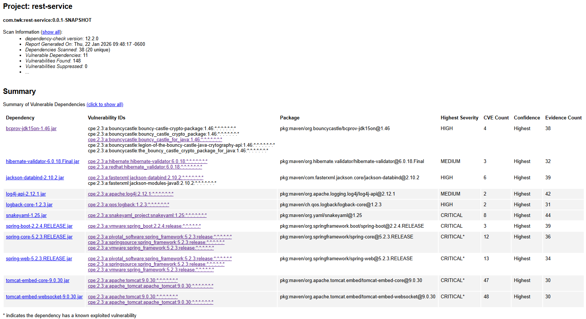

- bcprov-jdk15on-1.46.jar: The Bouncy Castle Crypto package is a Java implementation of cryptographic algorithms. This jar contains JCE provider and lightweight API for the Bouncy Castle Cryptography APIs for JDK 1.5 to JDK 1.7.
Recommend: Needs to be updated to the newest version.
- hibernate-validator-6.0.18.Final.jar: Hibernate's Bean Validation (JSR-380) reference implementation.
Recommend: Upgrade to the hibernate-validator-6.0.20.Final
- jackson-databind-2.10.2.jar: General data-binding functionality for Jackson; works on core streaming API
Recommend: Update to version 2.13.0 or newer
- log4j-api-2.12.1.jar: The Apache Log4j API
Recommend: Users should upgrade to version 2.25.3
- logback-core-1.2.3.jar: logback-core module
Recommend: Upgrade to the 1.5.x series
- snakeyaml-1.25.jar: YAML 1.1 parser and emitter for Java
Recommend: Use SnakeYaml SafeConstructor when parsing untrusted content to restrict deserialization and upgrade to version 2.0 and beyond
- spring-boot-2.2.4.RELEASE.jar: Spring Boot
Recommend: Users should upgrade to either version 3.0.6+ or 2.7.11+ as the model being used is unsupported
- spring-core-5.2.3.RELEASE.jar: Spring Core
Recommend: Users should upgrade to version 5.3.17+ and apply updates per vendor instructions
- spring-web-5.2.3.RELEASE.jar: Spring Web
Recommend: Upgrade to version 5.3.16 or newer and apply updates per vendor instructions
- tomcat-embed-core-9.0.30.jar: Core Tomcat Implementation
Recommend: Upgrade to versions 9.0.31, 8.5.51, 7.0.100 or later
- tomcat-embed-websocket-9.0.30.jar: Core Tomcat Implementation
Recommend: Upgrade to versions 9.0.31, 8.5.51, 7.0.100 or later

5. Mitigation Plan
Interpret the results from the manual review and static testing report. Then identify the steps to mitigate the identified security vulnerabilities for Artemis Financial’s software application.

Many of the safety risks can be fixed quickly by updating the files that are outdated. Once the dependencies are updated to the newest versions we can work on other updates to the program. The first step we should take following the updates to the dependencies is to switch to HTTPS for the application’s communication as that is a more secure way of communicating between the client and the server. We will also need to clean up the code to remove so many of the public accessors and constructors to help ensure security. Lastly we need to make certain that all of our systems are up to date as unsupported programs are more at risk to attacks.

